Arm System Geometry SWHD Operator

1 Revision History 1
2 Introduction 1
3 PUSH Arm 2
4 PULL Arm 5
5 sliding PUSH arm 8
6 ST Arm 13
7 References 16

Revision History
Rev | Date | Issuer | Authorized | Description
0.0 | 10-09-15 | SESAJ | N/A | First draft
0.1 | 11-02-09 | SETA | N/A | Added Push 210 and fixed α or β angle. Second draft.
0.2 | 11-02-24 | SETA | N/A | Added sliding push.
0.3 | 11-07-28 | SETA | N/A | Corrected Push “S” distance to 193.7mm
0.4 | 11-10-19 | SETA | N/A | Corrected equations
0.5 | 13-03-13 | JGR | N/A | Added Push 180 arm system
0.6 | 14-01-15 | JGR | N/A | Added PULL 220mm arm system

Introduction

Description of geometry in the possible arm system configurations in SWHD operator. Equations for door angle as a function of arm angle.

PUSH Arm

Equations are valid for a left hanged door. For a right hanged door, equations are dashed if they differ from a left hanged door.
Equations below are used when calculating the speed trajectories for a door with a PUSH arm, see References. Excel document for PUSH arm are valid for a right hanged door.

Geometry for PUSH arm
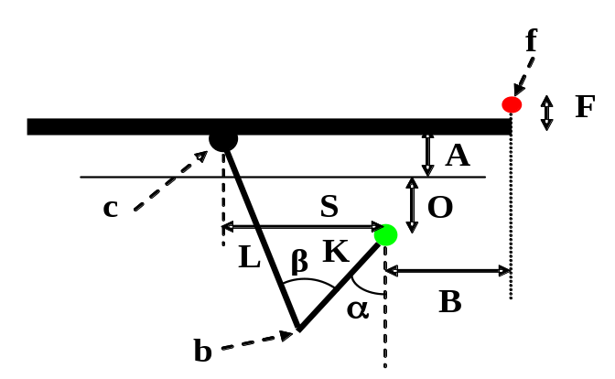
Figure 1, Arm system PUSH on right hanged door

o = Green point is drive centre.
f = Red point is hinge centre.
b = Arm system knee point.
c = Telescope arm point to bracket in door.
C = Distance between point c and door. (25 mm)
F = Distance hinge centre to door plus door thickness set to 15 + 50 = 65 mm.
A = Reveal could be 0 -- 305 mm (0—12”).
O = Distance frame to drive centre can be 55+12=67 mm or 76.2 mm (3”).
S = Distance arm point in door to drive centre is set to 193.7 mm (10.5” + 0.875” – 3.75”) or 60,3mm (2.375”).
B = Distance hinge centre to drive centre is set to 70 mm, 95.25 mm or 210mm.
L = Telescope arm length is adjustable from 265mm to 620mm.
K = Turning arm fix length is set to 250 mm.
α = Arm angle. Increasing clock-wise. Zero in south direction (270 deg normal). Could be adjusted to a fixed value, when the door is closed, using the telescope arm length L.
β= Arm-to-arm angle. Could be adjusted to a fixed value when the door is closed using the telescope arm length L.
α_{D}= Door angle (see Figure 3)

The PUSH combinations are identified by the hinge centre to drive centre distance B.
B (mm) | O (mm) | S (mm) | A (mm) | F (mm) | C (mm) | K (mm) | L(mm)
70 | 76.2 | 193.7 | 0-305 | 65 | 25 | 250 | 300-600
95 | 67 | 193.7 | 0-305 | 65 | 25 | 250 | 300-600
95 | 76.2 | 193.7 | 0-305 | 65 | 25 | 250 | 300-600
210 | 67 | 60.3 | 0-305 | 65 | 25 | 250 | 280-600
Table 1, parameter summary with possible combinations

Equations for PUSH arm
Drive centre is set to origo in an x-y coordinate system.
Find equations for points b, c and finally α_{D}.

- Start with telescope arm length. It can either be dependent on α or on β. L then varies with variable length distances A, O and the angle α or β.
L for a fixed α.
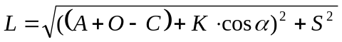

L for a fixed β.
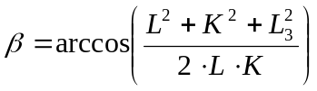 (cosine theorem)
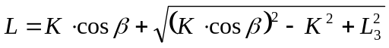 (Usable root from quadratic equation)

L for the special case “Push 210” where the arm is perpendicular to the door
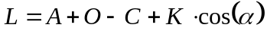
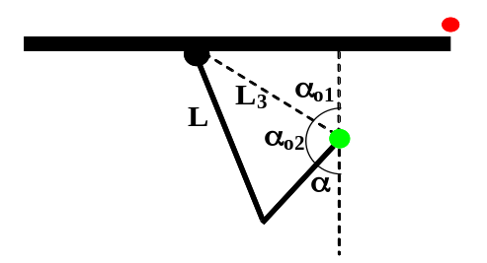
Figure 2, α angle close-up

- Arm system initial angle at closed door.
Distance drive centre to point c in door.
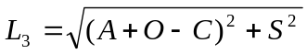
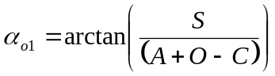
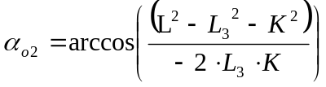
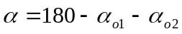
In the Push 210 case the arm is perpendicular to the door and the initial angle at closed door becomes
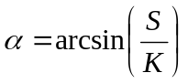
and since S and K are fixed values, α = 13.96 degrees for a closed 210 door.

- Arm system knee point b.
b_{x} = -K * sin(α)
b_{x} = K * sin(α)
b_{y} = K * cos(α)

- Hinge point f
f_{x} = B
f_{x} = -B
f_{y} = F + A + O

- Distance between point b and hinge centre.
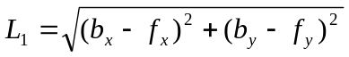

- Distance between point c and hinge centre.
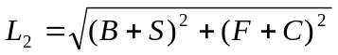

- Door angle consist of three parts.
α_{D} = α_{D1} + α_{D2} + α_{D3} - 90
α_{D1} = acos((f_{y} - b_{y})/L1)
α_{D2} = acos((L² – L₁²-L₂²)/(-2*L₁*L₂)) (Cosine theorem)
α_{D3} = atan((F+C)/(B+S))

- Arm system point c.
c_{x} = -L₂ * cos(α_{D}-α_{D3}) + f_{x}
c_{x} = L₂ * cos(α_{D}-α_{D3}) + f_{x}
c_{y} = L₂ * sin(α_{D}-α_{D3}) + f_{y}

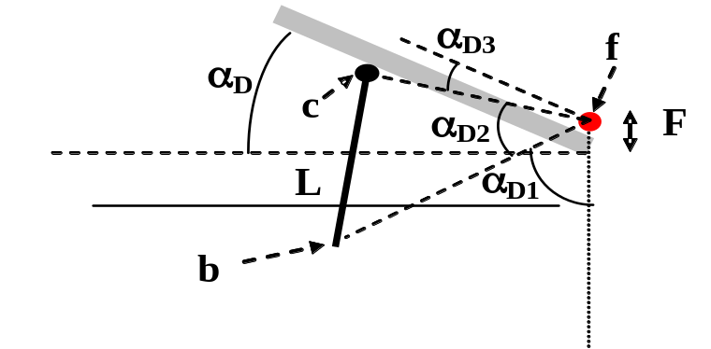
Figure 3, Door angle in Push arm system

PULL Arm
Equations are valid for a right hanged door. For a left hanged door, equations are dashed if they differ from a right hanged door.
Equations below are used when calculating the speed trajectories for a door with a PULL arm, see References. Excel document for PULL arm are valid for a left hanged door.

Geometry for Pull arm

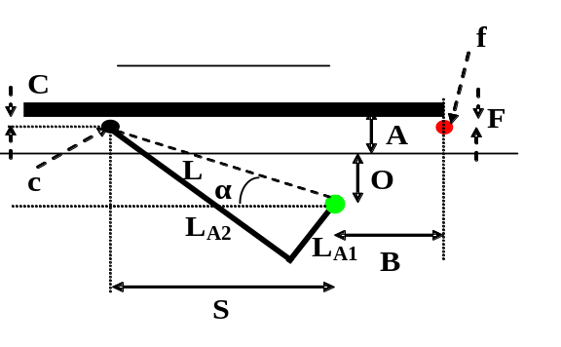
Figure 4 Arm system Pull on left hanged door

o = Green point is drive centre.
f = Red point is hinge centre.
c = Pull arm point in door strip.
F = Distance hinge centre to door set to 15 mm.
A = Reveal could be 0 -- 130 mm.
O = Distance frame to drive centre is set to 67 mm or 76.2 mm.
S = Distance arm point in door strip to drive centre (see equation below).
B = Distance hinge centre to drive centre is set to 70 mm, 95.25 or 210 mm.
L = Distance between o and c. Set to 400 mm for normal Pull arm system and 220 mm for PULL 220mm arm system.
LA1, LA2 = Pull arm lengths. LA1 is set to 117 and LA2 is set to 279.
C = Distance door to door strip centre is set to 17.5 mm.
α = Arm angle. Increasing counter clock-wise. Zero in west direction(180 deg normal).
α_{D}= Door angle see Figure 5.

Equations for Pull arm
Drive centre is set to origo in an x-y coordinate system.
Find equations for point c and finally α_{D}.
- Start with distance arm point in door strip to drive centre at closed door.
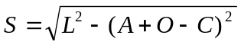

- Distance between point c and hinge centre at closed door.
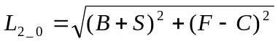

- Arm system initial angle at closed door.
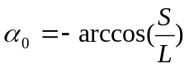

- Arm system point c.
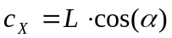
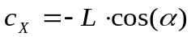
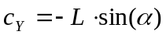

- Hinge point f.
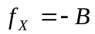
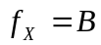
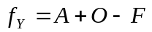

- Distance between point c and hinge centre.
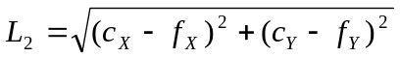

- Door angle consist of two parts.
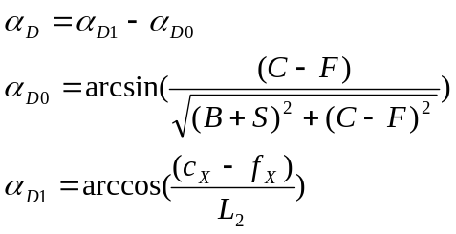
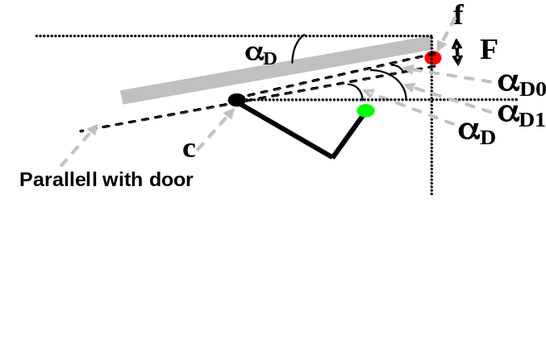
Figure 5 Door angle in Pull arm system

Geometry for sliding PUSH arm

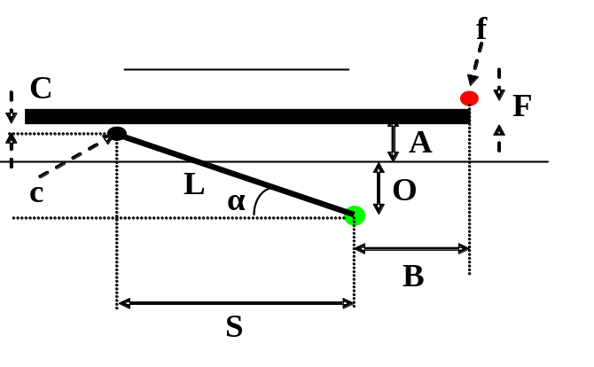
Figure 6 Arm system sliding PUSH on right hanged door

o = Green point is drive centre.
f = Red point is hinge centre.
c = Push arm point in door strip.
F = Distance hinge centre to door including door thickness 65 mm.
A = Reveal could be 0 -- 114 mm (including door thickness)
O = Distance frame to drive centre is set to 67 mm.
S = Distance arm point in door strip to drive centre (see equation below).
B = Distance hinge centre to drive centre is set to 210 mm.
L = Distance between o and c. Set to 400 mm.
C = Distance door to door strip centre is set to 18 mm.
α = Arm angle. Increasing counter clock-wise. Zero in west direction(180 deg normal).
α_{D}= Door angle see Figure 5.

Equations for sliding PUSH arm
Drive centre is set to origo in an x-y coordinate system.
Find equations for point c and finally α_{D}.

- Start with distance arm point in door strip to drive centre at closed door.
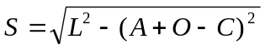

- Distance between point c and hinge centre at closed door.
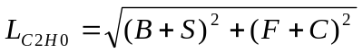

- Arm system initial angle at closed door.
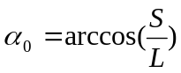

- Arm system point c.
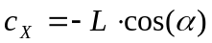
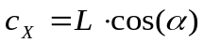
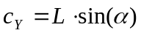

- Hinge point f.
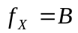
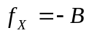
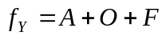

- Distance between point c and hinge centre.
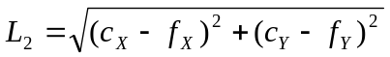

- Door angle consist of two parts.
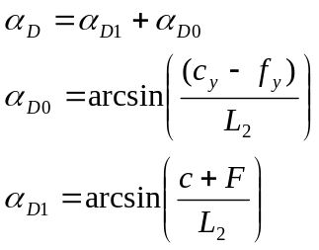
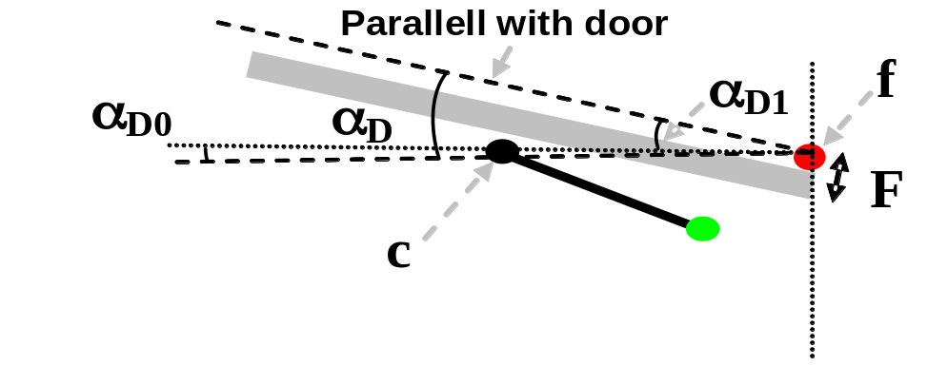
Figure 7 Door angle in sliding PUSH arm system

Geometry for sliding PUSH 180 arm
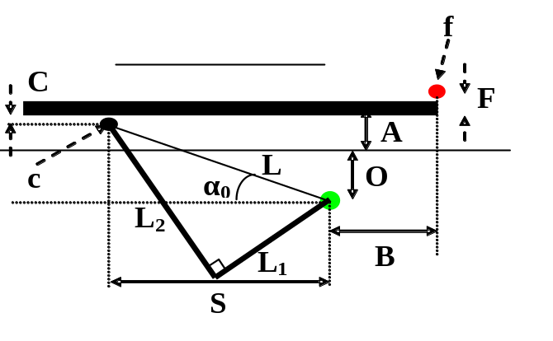
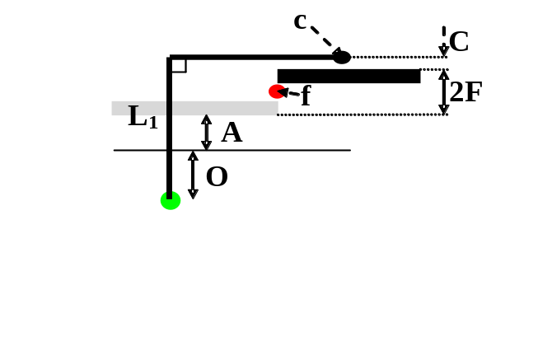
Figure 8 Arm system sliding PUSH on right hanged door

o = Green point is drive centre.
f = Red point is hinge centre.
c = Push arm point in door strip.
F = Distance hinge centre to door including door thickness 65 mm.
A = Reveal could be 0 -- 305 mm
O = Distance frame to drive centre is set to 67 mm.
S = Distance arm point in door strip to drive centre (see equation below).
B = Distance hinge centre to drive centre is set to 95 mm
L1 = Telescopic leg on armsystem. The length depends on reveal .
L2 = Fixed leg on armsystem, set to 290 mm
C = Distance door to door strip centre is set to 18 mm.
α = Arm angle. Increasing counter clock-wise, zero degrees at closed position.
α_{D}= Door angle see Figure 9.

Equations for PUSH 180 arm
Drive centre is set to origo in an x-y coordinate system.
Find equations for point c and finally α_{D}.

- Calculate L
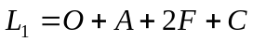, 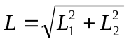
- Start with distance arm point in door strip to drive centre at closed door.

- Distance between point c and hinge centre at closed door.

- Arm system initial angle at closed door.

- Arm system point c.
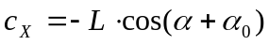
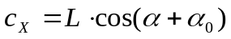
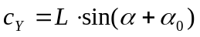

- Hinge point f.

- Distance between point c and hinge centre.
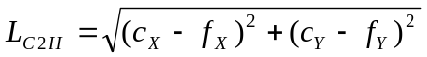

- Door angle consist of two parts.
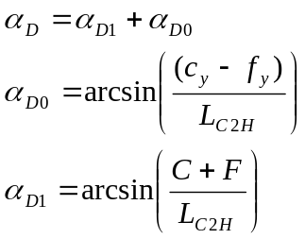
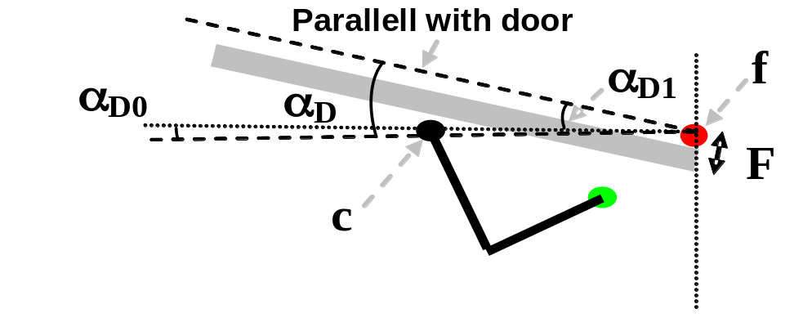
Figure 9 Door angle in PUSH 180 arm system

ST Arm
Equations are valid for a right hanged door. For a left hanged door, equations are dashed if they differ from a right hanged door.
Equations below are used when calculating the speed trajectories for a door with a ST arm, see References. Excel document for ST arm are valid for a left hanged door.

Geometry for ST arm
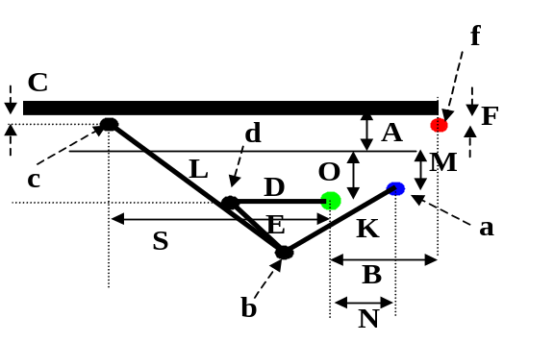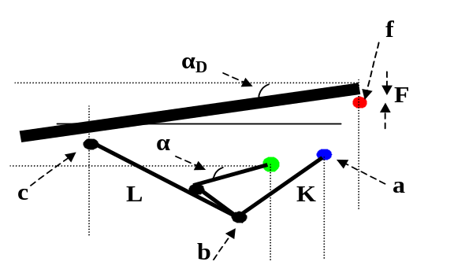

Figure 10 Arm system ST on right hanged door

o = Green point is drive centre.
f = Red point is hinge centre.
b = Main (boomerang) arm knee point.
c = Pull arm point in door strip.
F = Distance hinge centre to door set to 16 mm.
A = Reveal could be 0 -- 130 mm.
O = Distance frame to drive centre is set to 63,5 mm or 76.2 mm.
S = Distance arm point in door strip to drive centre (see equation below).
B = Distance hinge centre to drive centre is set to 70 mm or 95.25 mm
D = Drive arm length is set to 165 mm.
E = Middle arm length is set to 215 mm.
K = Main (boomerang) arm fix length is set to 190 mm.
L = Main (boomerang) arm variable length is reveal dependent (se equation below).
M = Distance frame to main arm fix point a is set to 33,5 mm.
N = Distance drive arm centre to main arm fix point a is set to 143 mm.
C = Distance door to door strip centre is set to 20 mm.
α = Arm angle. Increasing counter clock-wise. Zero in west direction (180 deg normal).
α_{D}= Door angle.

Equations for ST arm
Drive centre is set to origo in an x-y coordinate system.
Find equations for points b, c and finally α_{D}.
Assume reveal A=75 mm in calculations below.

- Start with angle in point a when closed door. See also Figure 11.
α_{a} = α_{a1} + α_{a2}
α_{a1} = atan(O-M/ (D+N)) *180/pi = atan((63,5-33,5)/(165+143)) *180/pi = 5,56

L1_{C} = sqrt((O-M)^2 + (N+D)^2) = sqrt(63,5-33,5)^2 + (165+143)^2)= 309,5
α_{a2} = acos(K^2 + L1_{C}^2 –E^2)/(2*K*L1 _{C})*180/pi = , Cosine theorem acos((190^2 + 309,5^2-215^2)/(2*190*309,5)) *180/pi = 43,26
α_{a} = α_{a1} + α_{a2 =} 5,56 + 43,26 = 48,82

- Main (boomerang) arm system knee point b when closed door.
b_{x} = -K * cos(α_{a} * pi/180) + N = -190 * cos(48,82*pi/180) + 143 = 17,90
b_{x} = K * cos(α_{a} * pi/180) - N = 190 * cos(48,82*pi/180) - 143 = -17,90
b_{y} = -K * sin(α_{a} * pi/180) +O-M = -190 * sin(48,82*pi/180) +63,5-33,5 = -113,0

- Main (boomerang) arm variable length is reveal dependent.
L = (O+A-C-b_{y})/(cos((10+α_{a})*pi/180)) = (63,5 + 75 – 20 – (-113,0)/cos((10+48,82)*pi/180)= 447,1

- Distance arm point in door strip to drive centre when closed door.
S_{C} = L* sin((10+α_{a} )*pi/180) = 447,1 * sin((10+48,82)*pi/180) = 382,5

- Hinge point f.
f_{x} = B = 291
f_{x} = -B = -291
f_{y} = A + O – F = 75 + 63,5 – 16 = 122,5

- Arm system knee point d.
d_{x} = -D * cos(α * pi/180)
d_{x} = D* cos(α * pi/180)
d_{y} = -D * sin(α * pi/180)

- 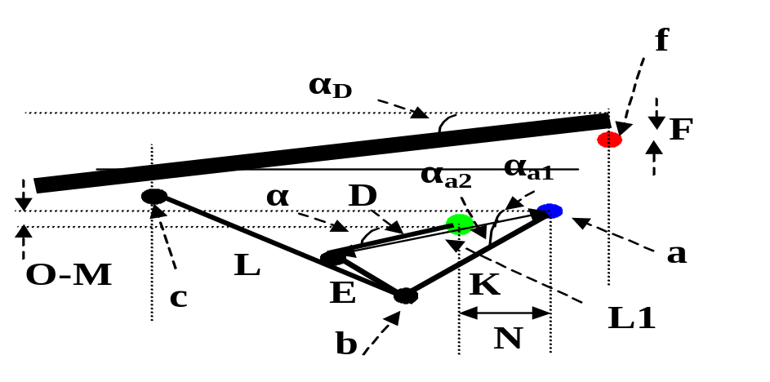Angle in point a.

Figure 11 Arm system ST α_{a} calculation

α_{a} = α_{a1} + α_{a2}
L1 = sqrt((N- d_{x})^2 + (O-M- d_{y})^2 )
α_{a1} = acos((N - d_{x} )/L1)*180/pi
α_{a2} = acos(K^2 + L1^2 –E^2)/( 2*K*L1 )*180/pi , Cosine theorem
L1 = sqrt((N+ d_{x})^2 + (O-M- d_{y})^2 )
α_{a1} = acos((N + d_{x} )/L1)*180/pi
α_{a2} = acos(K^2 + L1^2 –E^2)/(2*K*L1 )*180/pi

- Main (boomerang) arm system knee point b.
b_{x} = -K * cos(α_{a} * pi/180) + N
b_{x} = K * cos(α_{a} * pi/180) - N
b_{y} = -K * sin(α_{a} * pi/180) +O-M

- Arm system point c in door strip.
c_{x} = -L * sin((10+α_{a}) * pi/180) + b_{x}
c_{x} = L * sin((10+α_{a}) * pi/180) + b_{x}
c_{y} = L * cos((10+α_{a}) * pi/180) + b_{y}

- Distance arm point in door strip to hinge centre.
L2 = sqrt((c_{x}-f_{x} )^2 +(c_{y}-f_{y} )^2

- Door angle consist of two parts. Similar to PULL arm.
α_{D} = α_{D1} - α_{D0}
α_{D0 =} asin((C - F)/ sqrt((B+S_{C})^2+( C-F)^2) *180/pi = asin((20-16)/sqrt((291+382,5)^2+(16-20)^2)*180/pi= 0,34
α_{D1 =} acos((c_{x} - f_{x})/L2) *180/pi

References

1. | Hastighetsberäkningar\PUSH_POS_CTRL v0.4.xls
2. | Hastighetsberäkningar\PULL_POS_CTRL v0.2.XLS
3. | Hastighetsberäkningar\ST_POS_CTRL v0.2.XLS

